

**Entering Grades Using the Faculty Grade Assignment channel in goPFW**

1. **Go to goPFW at** [**https://go.pfw.edu**](https://go.pfw.edu)**, enter your assigned Purdue Fort Wayne network account username and password, and click Sign-In.**



1. **After successfully logging in to goPFW, click on the Faculty tab and then locate the Faculty Grade Assignment portlet in the left hand column.**

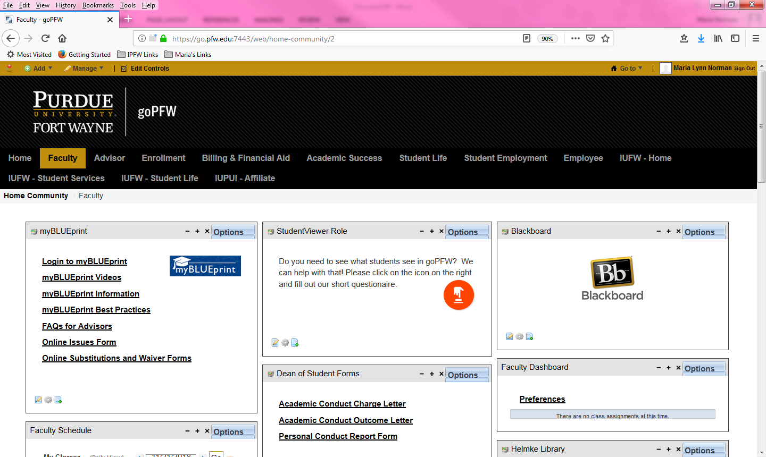

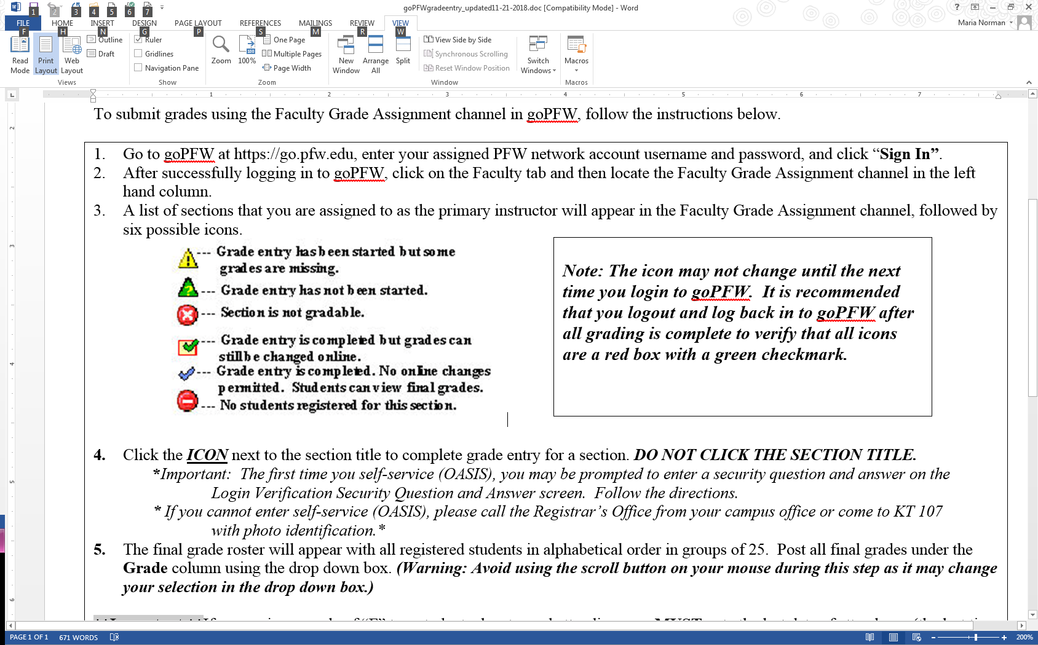

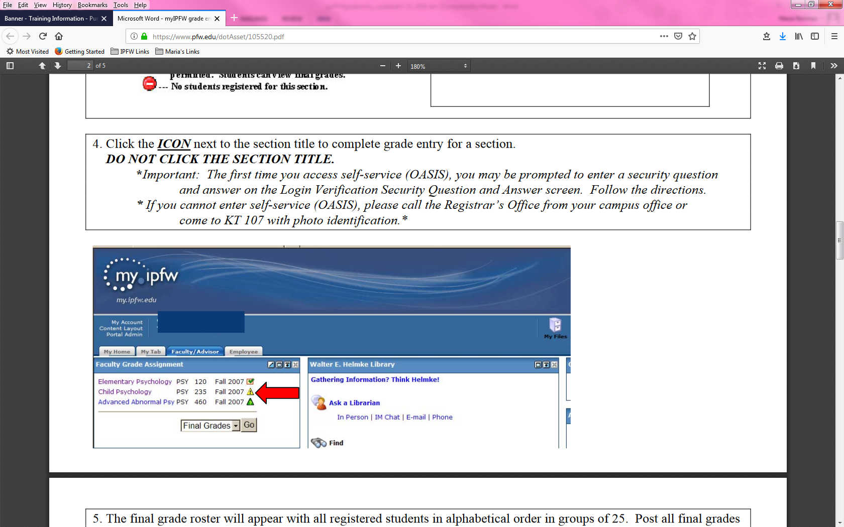

**5. The final grade roster will appear with all registered student in alphabetical order in groups of 25. Post all final grades under the Grade column using the drop down box. (Warning: Avoid using the scroll button on your mouse during this step as it may change your selection in the drop down box.) Leave the Attend Hours fields blank.**

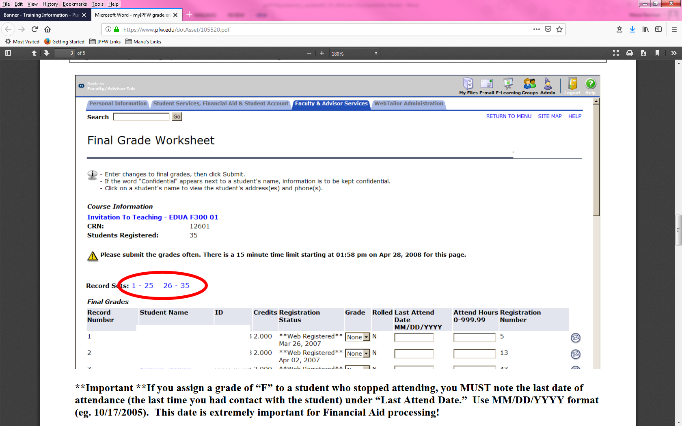

**\*\*Important** If you assign a grade of “F” to a student who stopped attending, you MUST note the last date of attendance (the last time you had contact with the student) under “Last Attend Date.” Use MM/DD/YYY format (eg. 10/17/2018). This date is extremely important for Financial Aid processing! <Photo on next page>**

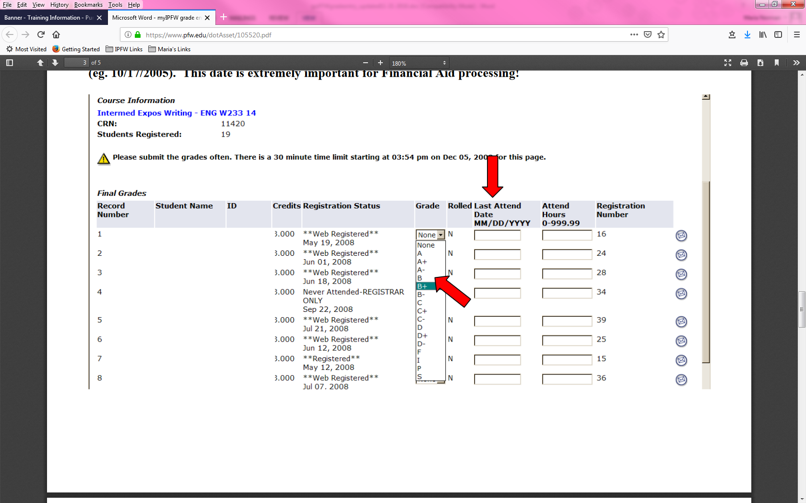

**6. When finished, click “Submit.” If you fail to click the “Submit” button, your grades will not be entered into the system. You must submit information within a 15-minute time period or you will be logged out of the system. Please note the system will not allow a “W” grade to be given or changed.**

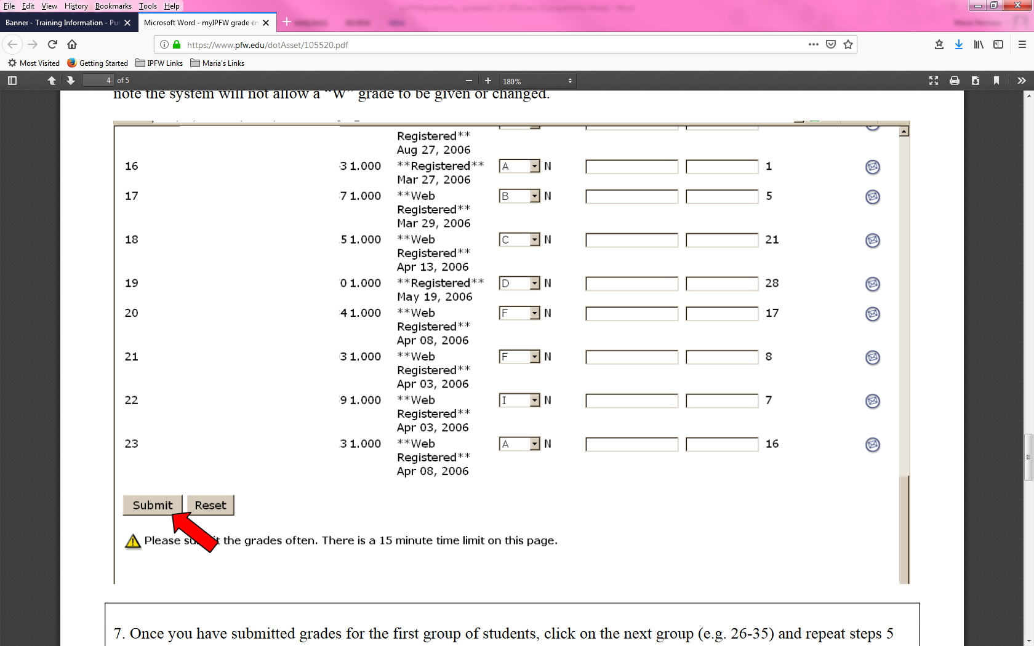

**7. Once you have submitted grades for the first group of students, click on the next group (e.g. 26-35) and repeat steps 5 and 6. If the section has 25 or less students, this step is not necessary.**

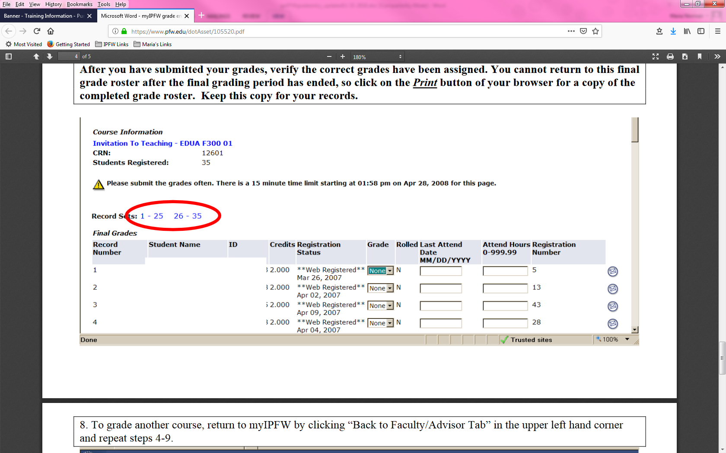

**8. To grade another course, return to goPFW by clicking “Back to Faculty Tab” in the upper left hand corner and repeat steps 4-9.**

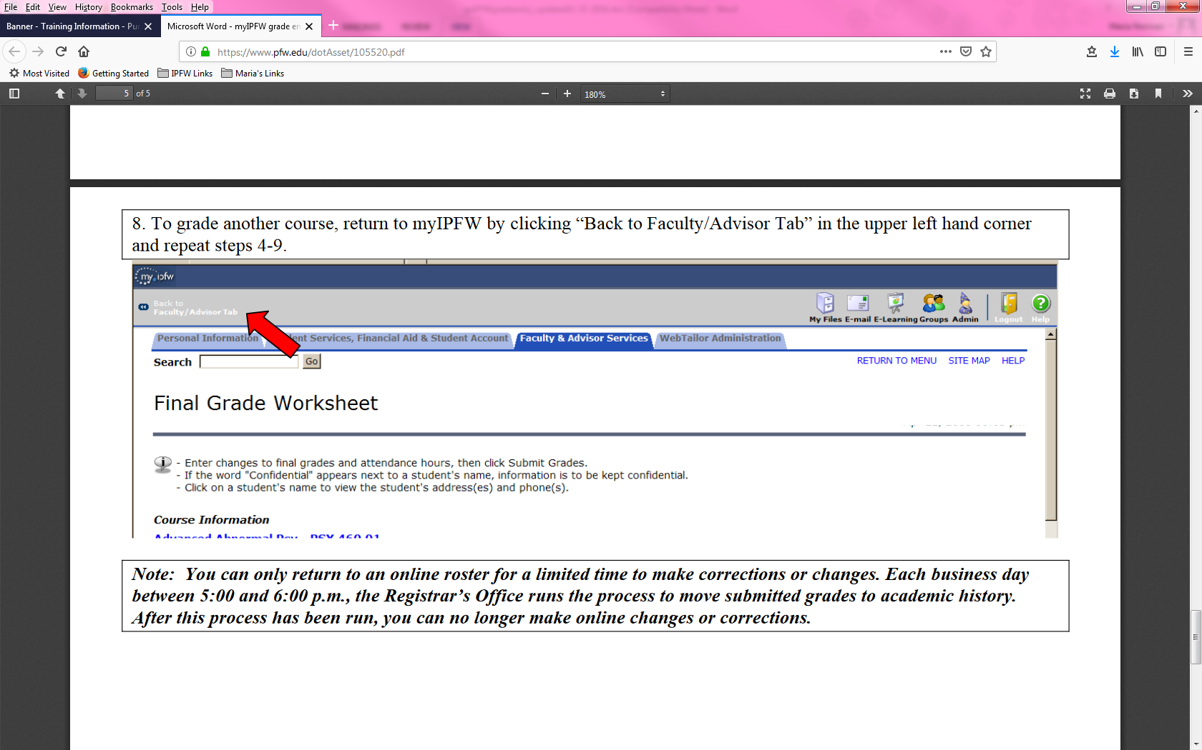

**Note: You can only return to an online roster for a limited time to make correction or changes. Each business day between 5:00pm and 6:00 pm, the Registrar’s Office runs the process to move submitted grades to academic history. After this process has been run, you can no longer make online changes or corrections.**